Chapter 1 – Basic Algebraic Methods

Lesson 1-1: Real Numbers, Variables, and Exponents
Algebra is generalized arithmetic that uses both letters and numbers. These letters, called variables, are placeholders for unknown numbers.

Ordering Real Numbers on a Number Line
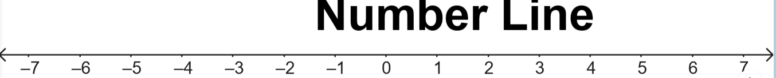

Classifying Numbers
- Integers – Counting Numbers
- Rational numbers – Numbers that can be expressed as fractions.
- Irrational numbers

Absolute Value
The absolute value of a real number is always non-negative numbers. Written as $|x|$.

Using Symbols to Make Comparisons

Laws of Integer Components
- Base – the number that is raised to a power
- Exponent – The integer number of times the base is multiplied by itself.

- Multiplication law of exponents:
$$a^{x}⋅a^{y}=a^{x+y}$$
- Quotient law of exponents:$$\frac{a^{x}}{a^{y}}=a^{x-y}$$
- Power of a power law of exponents:
$${(a^{x})}^{y}=a^{xy}$$

- Zero exponent law:
$$a^{0}=1$$

- Negative exponent law:
$$a^{-x}=\frac{1}{a^{x}} and\frac{1}{a^{-x}}=a^{x}$$

Lesson 1-2: Solving Linear Equations

Key Ideas
An equation is a mathematical statement that uses an equal (=) symbol to indicate that two quantities have the same value.

Some Terms Related To Solving Equations
- The domain of a variable is the set of all possible values that the variable can have.
- Solving an equation means finding all values in the domain of the variable for which the equation is true. Each of the values is a solution or root of the equation. The collection of all roots of an equation is the solution set.
- Equivalent equations are equations that have the same solution set.
- A linear equation in variable $x$ is an equation that can be written in the form $ax+b=0$, where $a$ and $b$ are constants that stand for real numbers with $a≠0$.

General Strategy for Solving a Linear Equation
To solve a linear equation, transform the original equation into one or more equivalent equations until the variable is isolated on one side of the equal symbol with a coefficient of 1.

Solving a Linear Equation Using Inverse Operations

Solving a Proportion
A proportion is an equation that states two fractions are equal.

Solving an Equation with Like Terms
Terms such as $4x$ and $5x$ are called like terms since they differ only in their numerical coefficients, 4 and 5.
To solve an equation in which the variable appears in more than one term, first combine like terms.

